Adaptive Lighting System

This is the first system in our project. A rough sketch of the circuit is given below:

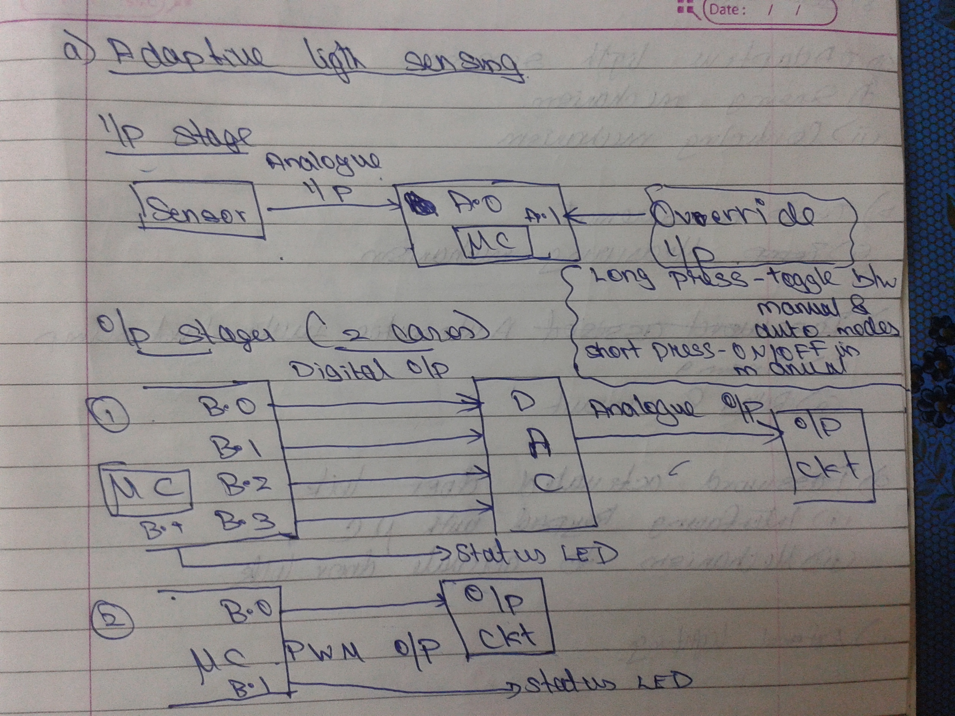

PS: A.0,A.1,B.0,B.1 denotes the pins of the microcontroller.

Input Stage

The input stage consists of two inputs:
1) Sensor Analogue input
2) Override input

The sensor analogue input is fed into one of the ADC pins of the microcontroller which is then compared with pre-set vales and a corresponding output is produced.

The override input is used for two functions(this design is what I have in mind and it might not be correct and anyone can change this or bring about any modification). One function is that it is used to switch between the manual mode and the auto mode. In auto mode the intensity is adaptively controller by the microcontroller and in manual mode the user can manually turn it on and off.

A long press of the switch will toggle the mode of operation. This can be implemented as follows. Whenever a high signal is encountered on the line, the microcontroller calls an interrupt(ISR) function. In that function we code the actions. Now initially in the function, there is a code that checks for how long the switch is pressed(i.e. signal is high). It can be determined by checking the pin after a second of the initial press. Now if the press is long, then mode of operation is toggled.

If the present mode is manual and the presses are short, the light is toggled on and off. In auto mode, short presses do not result in an action. That's all with the input part.

Output Stage:

The output stage can be implemented in two ways as shown in the above figure.
1) PWM method
2) DAC method

In the PWM method, the intensity of the light is controlled by a PWM signal from the microcontroller. We switch the LED on and off fast so that our eyes cannot distinguish between the on and off states but in effect only less intensity is produced making the led less brighter. The brightness of the led can be controlled by the duty cycle of the PWM signal(on and off time). But then to avoid flickering, i.e. to avoid our eyes to see that toggling, the wave should be of sufficient frequency. 16Hz is the threshold of persistance, but then the std frequency used in TVs is 50Hz.

There is a small doubt that I've with PWM generation. i.e. like once if we specify the pwm output at a pin, will the output be always a PWM in that pin, even we are doing other functions like reading another pin etc. Like consider I specify PWM output at pin A.1. Now after that, I read pin B.0 and output into pin B.1 and then check for some values etc. etc. So then while performing all these tasks the output of the pin A.0 will be a PWM wave that I've declared earlier right..? So angane anenkil, we can give the function in the main loop of the program that keeps on checking the input from the sensor and produce PWM waves. The only issue with the above method is that, while say entering the password for the door lock, the loop will be halted(well I ain't sure of how does the microcontroller work while receiving input from the keypad). So then only after the door has been unlocked, the loop will execute again and hence will only then change the light according to the intensity. But then these things, I don't think we have to consider since we are doing a mini project.

In the second method, it uses a DAC that converts the digital output of the microcontroller into analogue varying output that is fed into the output circuit. The variations will vary the brightness of the LED. This is only required if the PWM is not working in the way stated above.

Also we've another output, i.e. the status LED. It shows the present mode of operation of the system. Say in automatic mode the LED will be constantly blinking slowly. When we make a long press, the LED will blink fast for a sec showing that the mode of operation has been changed. In the manual mode, the LED is off when the light is off and on when light is on.

Well one trade off that we cannot avoid as stated above is that, while doing one thing, like say entering the password, the other controls cannot be accessed like say toggling the light. But then that we can neglect since it's a mini project.

So that’s all with the basic overview and as stated earlier, this is just a rough sketch that came across my mind and make sure you guys modify this to make it more efficient and faster. Also do correct the errors and make the required changes in the system, circuit and design. Incorporate whatever new things that you guys have learned from the workshop.

